How to activate Microsoft Windows

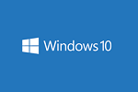

After the Microsoft Toolkit is downloaded, you should disable your antivirus systems from your computer to extract the downloaded file. Then only you can install the toolkit and activate Windows on your computer. Here, the steps for you to activate Windows.

### **Microsoft Windows Activation Steps**

**Step. 01:** First, open the [Microsoft Toolkit](https://mstoolkit.org/download-microsoft-toolkit/).

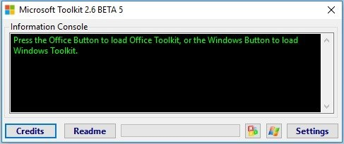

**Step. 02:** Then, click on the **Microsoft Windows logo** which is located below the toolkit window.

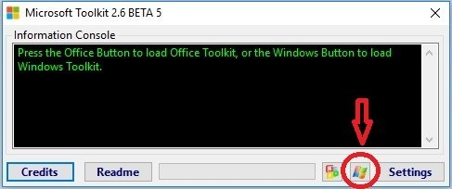

**Step. 03:** Now, you can see a new window pop-up with many options.

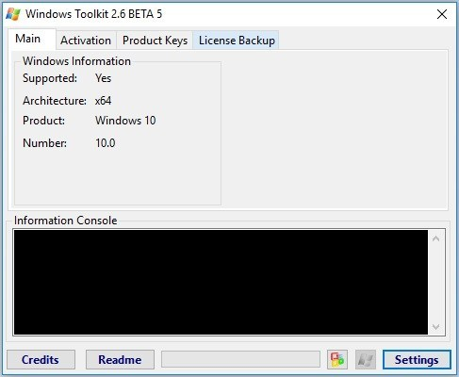

**Step. 04:** Here, activation tab you should click on the **EZ Activator** and wait for a few seconds.

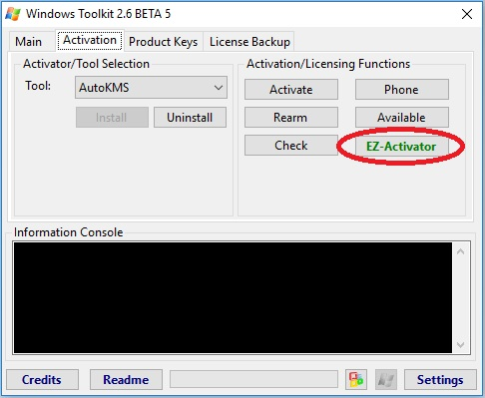

**Step. 05:**After a few seconds, your Microsoft Windows activation is completed.

